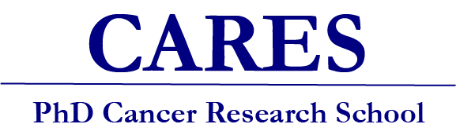

Invitation to all PhD students in cancer research at Lund University and University of Gothenburg to apply to become a research fellow in the new CARES program 2026-2027

The Cancer Research South (CARES) school was initiated in 2014 with support from the Swedish Cancer Society. The research school was relaunched in a new format, starting in January 2022. The new CARES format comprises a range of activities, including both on-line courses, retreats and an exchange program, with the overarching goal to provide you as a PhD student with a unique possibility to broaden your knowledge in all aspects of comprehensive translational cancer research. In the new format we have had 72 students so far and they are now our CARES Alumni. We are aiming for approximately 30 students per 18-month cycle, with an equal distribution of clinical and pre-clinical fellows.

Research school content

The primary goal of the CARES school is to provide a combination of comprehensive courses while the fellows acquire a deepened insight into the spectrum of activities available within modern cancer research. This will empower the fellows to reflect on the most important concepts in cancer research today and incorporate this knowledge into their own research. The aim is to provide an interactive, interdisciplinary research school covering state-of-the-art methodology and fostering skilled cancer research fellows.

Within the 18-month program the research school will comprise:
- 2 one-day retreats and 2 two-day retreat, thematically organized (24-25 Sep 2026, 21 Jan 2027, 20-21 May 2027, 11 Nov 2027)
- 4 online courses focusing on contemporary methods, including bioinformatics, single-cell sequencing, epigenetics and translational cancer research
- One online course covering clinical trials in cancer
- An exchange program between clinical and preclinical fellows

The curriculum is in English.

Application
Applications will be reviewed by an admissions committee, and students are selected on the basis of their academic record and personal motivation statement. To apply, please fill in the enclosed form. A letter of support from the supervisor, and a short CV (including a list of publications if there are any) are required. Applicants should have at least two years left of their PhD studies.
Please submit your application to
Johanna Verngren via e-mail: johanna.verngren@med.lu.se
Subject: CARES application

Deadlines
The first admission round will close April 15, 2026. You will be notified within two weeks whether you have been accepted or not. If required, a second admission round will be opened.

Coordinators
Lund University
Vinay Swaminathan (vinay.swaminathan@med.lu.se) and
Ingrid Hedenfalk (ingrid.hedenfalk@med.lu.se)
University of Gothenburg
Roger Olofsson Bagge (roger.olofsson.bagge@gu.se) and
Helena Carén (helena.caren@gu.se)

Application CARES school 2025-2026

Name:

Date of birth (personal number):

E-mail address (university email address):

Work address:

Date of PhD registration:

Planned date for thesis defense:

Main supervisor:

Do you have approval from your supervisor to attend the CARES school:

Short description of current PhD project (max. 150 words):

Motivation why you want to become a CARES fellow:

