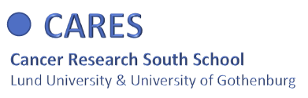
Invitation to all PhD students in cancer research at Lund University and University of Gothenburg to apply to become a research fellow in the new CARES program 2022-2023

The Cancer Research South (CARES) school was initiated 2014 with support from the Swedish Cancer Society. The research school is now relaunched in a new format, starting January 2022. The new CARES format comprises a range of activities, including both on-line courses, retreats and an exchange program, with the overarching goal to provide you as a PhD student a unique possibility to broaden your knowledge in all aspects of comprehensive translational cancer research. We are aiming for approximately 30 students per 18-month cycle, with an equal distribution of clinical and preclinical fellows.

Research school content

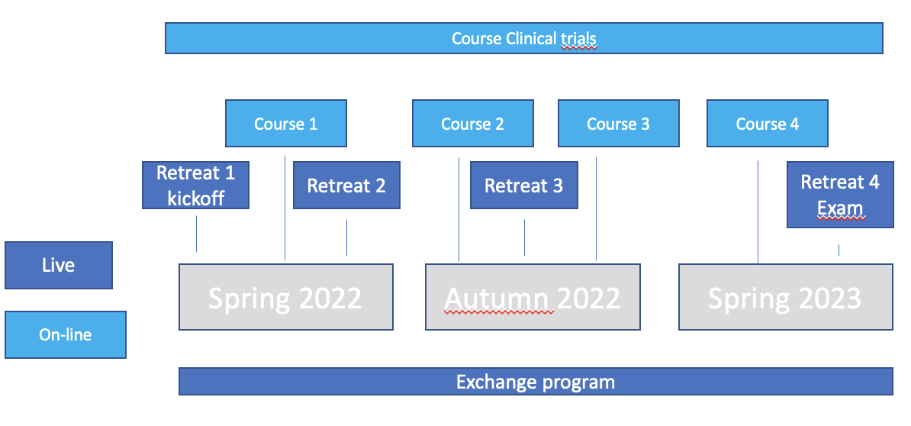

The primary goal of the CARES School is to provide a combination of comprehensive courses at the same time as the fellows acquire a deepened insight into the spectrum of activities within modern cancer research. This will empower the fellows to reflect on the most important concepts in cancer research today and incorporate this knowledge into their own research. The aim is to provide an interactive, interdisciplinary research school covering state-of-the-art methodology and fostering skilled cancer research fellows.

Within the 18-month program the research school will comprise:
- 4 one-day retreats, thematically organized
- 4 online courses focusing on contemporary methods, including bioinformatics, liquid biopsy, epigenetics and translational cancer research
- One online course in clinical trials in cancer
- An exchange program between clinical and preclinical fellows

The curriculum is in English.
Application
Applications will be reviewed by an admissions committee, and students are selected on the basis of their academic record and personal motivation statement. To apply, please fill in the enclosed form. A letter of support from the supervisor, a short CV (including a list of publications if there are any) is required. Applicants should have at least two years left of their PhD studies.
Please submit your application to
Johanna Verngren via e-mail: johanna.verngren@med.lu.se
Subject: CARES application
Deadlines
The first admission round will close September 15 2021. You will be notified within two weeks whether you have been accepted or not. If required, a second admission round will be opened.

Coordinators
Lund University
Ingrid Hedenfalk (ingrid.hedenfalk@med.lu.se) and
Håkan Axelson (hakan.axelson@med.lu.se)

University of Gothenburg
Roger Olofsson Bagge (roger.olofsson.bagge@gu.se) and
Helena Carén (helena.caren@gu.se)

Application CARES school 2022-2023

Name:

Date of birth:

E-mail address:

Work address:

Date of PhD registration:

Planned date for thesis defence: :

Supervisor:

Do you have the approval from your supervisor to attend these courses:

Short description of current PhD project (max. 150 words):

Motivation why you want to become a CARES fellow:

